**Assignment 19.2:**

Using udfs on dataframe

1. Change firstname, lastname columns into

Mr.first_two_letters_of_firstname<space>lastname

for example - michael, phelps becomes Mr.mi phelps.

**OUTPUT:**

**Load the file to RDD and create the data frame for the RDD.**

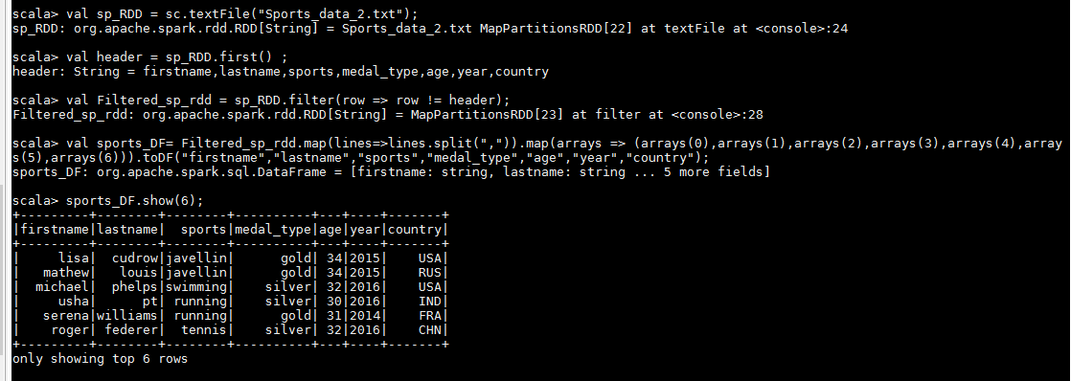

Create the UDF which convert the first name with Mr. Prefix.

And also drop the First and last name columns.

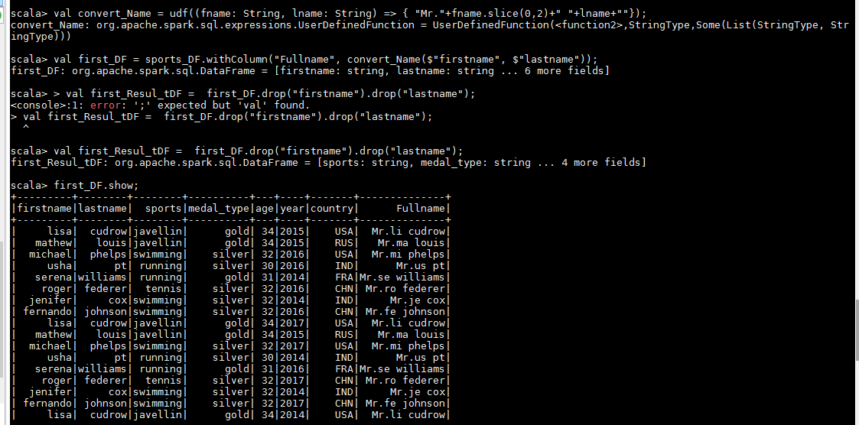

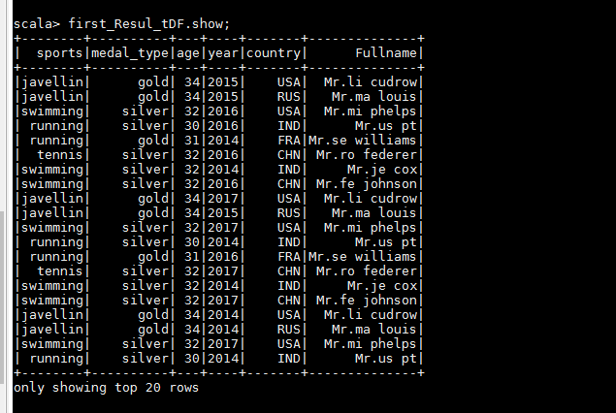

2. Add a new column called ranking using udfs on dataframe, where:

Gold medalist, with age >= 32 are ranked as pro

Gold medalists, with age <= 31 are ranked amateur

Silver medalist, with age >= 32 are ranked as expert

Silver medallists, with age <= 31 are ranked rookie.

Output:

Create UDF.

Add new column “**class**”into the created UDF.

